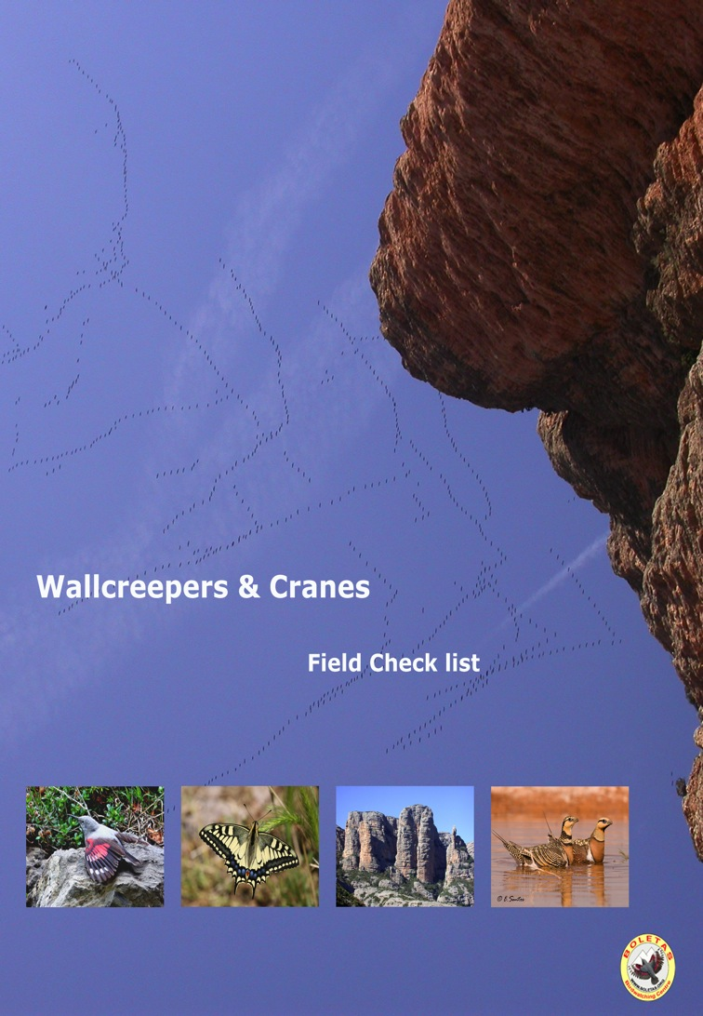
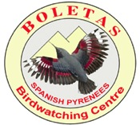
Birdwatching Holidays in Spain, Morocco & more…

BOLETAS Birdwatching centre
22192 Loporzano (Huesca) – Spain
tel/fax 00 34 974 262027 or 01162 889318
e.mail: jjsv@boletas.org // www.boletas.org
Esther Diago Millán - NIF 38493051K

DAYLY REGISTER

Day 1 -date________________ Weather_________________________________________________________________

Itinerary_________________________________________________________________________________________________

Day 2 -date________________ Weather_________________________________________________________________

Itinerary_________________________________________________________________________________________________

Day3 -date________________ Weather_________________________________________________________________

Itinerary_________________________________________________________________________________________________

Day 4 -date________________ Weather_________________________________________________________________

Itinerary_________________________________________________________________________________________________

Day 5 -date________________ Weather_________________________________________________________________

Itinerary_________________________________________________________________________________________________

Day 6 -date________________ Weather_________________________________________________________________

Itinerary_________________________________________________________________________________________________

Day 7 -date________________ Weather_________________________________________________________________

Itinerary_________________________________________________________________________________________________

Day 8 -date________________ Weather_________________________________________________________________

Itinerary_________________________________________________________________________________________________

RECOMMENDED SIGNS: Vista/Seen ( X ) º a/Heard ( H)

Abundant (+++) Common (++) Rare (+) Juvenile (Juv) Immature (Inm) Adult (Ad) Female Male

 | English and Spanish name |  | Scientific name | 1 |  | 2 |  |  | 3 |  | 4 |  | 5 |  | 6 |  | 7 |  | 8
 | LITTLE GREBE - ZAMPULLIN COMUN |  | Tachybaptus ruficollis
 | GREAT CRESTED GREBE -SOMORMUJO LAVANCO |  | Podiceps cristatus
 | BLACK-NECKED GREBE- ZAMPULLIN CUELLINEGRO |  | Podiceps nigricollis
 | GREAT CORMORANT - CORMORAN GRANDE |  | Phalacrocorax carbo
 | BITTERN - AVETOR COMUN |  | Botaurus stellaris
 | CATTLE EGRET - GARCILLE BUEYERA |  | Bubulcus ibis
 | LITTLE EGRET - GARCETA COMUN |  | Egretta garcetta
 | GREY HERON - GARZA REAL |  | Ardea cinerea
 | WHITE STORK – CIGÜEÑA BLANCA |  | Ciconia ciconia
 | GREYLAG GOOSE – ANSAR COMUN |  | Anser anser
 | COMMON SHELDUCK – TARRO BLANCO |  | Tadorna tadorna
 | WIGEON – SILBON EUROPEO |  | Anas penelope
 | GADWALL – ANADE FRISO |  | Anas strepera
 | COMMON TEAL – CERCETA COMUN |  | Anas crecca
 | MALLARD – ANADE AZULON |  | Anas platyrhynchos
 | NORTHERN PINTAIL – ANADE RABUDO |  | Anas acuta
 | GARGANEY – CERCETA CARRETONA |  | Anas querquedula
 | NORTHERN SHOVELER – PATO CUCHARA |  | Anas clypeata
 | RED-CRESTED POCHARD – PATO COLORADO |  | Netta rufina
 | COMMON POCHARD – PORRON COMUN |  | Aythya ferina
 | TUFTED DUCK – PORRON MOÑUDO |  | Aythia fuligula
 | RED KITE – MILANO REAL |  | Milvus milvus
 | LAMMERGEIER – QUEBRANTAHUESOS |  | Gypaetus barbatus
 | GRIFFON VULTURE – BUITRE LEONADO |  | Gyps fulvus
 | MARSH HARRIER – AGUILUCHO LAGUNERO |  | Circus aeruginosus
 | HEN HARRIER – AGUILUCHO PALIDO |  | Circus cyaneus
 | GOSHAWK – AZOR |  | Accipiter gentilis
 | SPARROWHAWK – GAVILAN |  | Accipìter nisus
 | COMMON BUZZARD – BUSARDO RATONERO |  | Buteo buteo
 | GOLDEN EAGLE – AGUILA REAL |  | Aquila chrysaetos
 | BONELLI´S EAGLE – AGUILA PERDICERA |  | Hieraaetus fasciatus
 | OSPREY – AGUILA PESCADORA |  | Pandion haliaetus
 | COMMON KESTREL – CERNICALO |  | Falco tinnunculus
 | MERLIN – ESMEREJON |  | Falco columbarius
 | HOBBY – ALCOTAN |  | Falco subbuteo
 | PEREGRINE FALCON – HALCON PEREGRINO |  | Falco peregrinus
 | RED-LEGGED PARTRIDGE – PERDIZ ROJA |  | Alectoris rufa
 | GREY PARTRIDGE – PERDIZ PARDILLA |  | Perdix perdix
 | WATER RAIL – RASCON |  | Rallus aquaticus
 | SPOTTED CRAKE – POLLUELA PINTOJA |  | Porzana porzana
 | COMMON MOORHEN – POLLLA DE AGUA |  | Gallinula chloropus
 | COMMON COOT – FOCHA COMUN |  | Fulica atra
 | COMMON CRANE – GRULLA COMUN |  | Grus grus
 | LITTLE BUSTARD – SISON |  | Tetrax tetrax
 | GREAT BUSTARD – AVUTARDA |  | Otis tarda
 | BLACK-WINGED STILT – CIGUEÑUELA | Himantopus himantopus
 | PIED AVOCET – AVOCETA | Recuvirostra avosetta
 | STONE CURLEW – ALCARAVAN | Burhinus oedicnemus
 | LITTLE RINGED PLOVER – CHORLITEJO CHICO | Charadrius dubius
 | GREAT RINGED PLOVER – CHORLITEJO GRANDE | Charadrius hiaticula
 | KENTISH PLOVER - CHORLITEJO PATINEGRO | Charadrius alexandrinus
 | DOTTEREL – CHORLITO CARAMBOLO | Charadius morinellus
 | GOLDEN PLOVER – CHORLITO DORADO | Pluvialis apricaria
 | GREY PLOVER – CHORLITO GRIS | Pluvialis squatarola
 | NORTHERN LAPWING – AVEFRIA | Vanellus vanellus
 | RED KNOT – CORRELIMOS GORDO | Calidris canutus
 | SANDERLING – CORRELIMOS TRIDACTILO | Calidris alba
 | LITTLE STINT – CORRELIMOS MENUDO | Calidris minuta
 | CURLEW SANDPIPER – CORRELIMOS ZARAPITIN | Calidris ferruginea
 | DUNLIN – CORRELIMOS COMUN | Calidris alpina
 | RUFF – COMBATIENTE | Philomachus pugnax
 | COMMON SNIPE – AGACHADIZA COMUN | Gallinago gallinago
 | WOODCOCK – CHOCHA PERDIZ | Scolopax rusticola
 | BLACK-TAILED GODWIT – AGUJA COLINEGRA | Limosa limosa
 | WHIMBREL – ZARAPITO TRINADOR | Numenius phaeopus
 | EURASIAN CURLEW – ZARAPITO REAL | Numenius arquata
 | SPOTTED REDSHANK- ARCHIBEBE OSCURO | Tringa erithropus
 | COMMON REDSHANK – ARCHIBEBE COMUN | Tringa totanus
 | COMMON GREENSHANK – ARCHIBEBE CLARO | Tringa nebularia
 | GREEN SANDPIPER – ANDARRIOS GRANDE | Tringa ochropus
 | WOOD SANPIPER – ANDARRIOS BASTARDO | Tringa glareola
 | COMMON SANDPIPER – ANDARRIOS CHICO | Actitis hypoleucos
 | BLACK-HEADED GULL – GAVIOTA REIDORA | Larus ridibundus
 | YELLOW-LEGGED GULL – GAVIOTA PATIAMARILLA | Larus cachinnans
 | BLACK-BELLIED SANDGROUSE – ORTEGA | Pterocles orientalis
 | PIN-TAILED SANDGROUSE – GANGA | Pterocles alchata
 | ROCK DOVE – PALOMA BRAVIA | Columba livia
 | STOCK DOVE – PALOMA ZURITA | Columba oenas
 | COMMON WOOD PIGEON – PALOMA TORCAZ | Columba palumbus
 | COLLARED DOVE – TORTOLA TURCA | Streptopelia decaocto
 | TURTLE DOVE –TORTOLA COMUN | Streptopelia turtur
 | BARN OWL – LECHUZA COMUN | Tyto alba
 | EAGLE OWL – BUHO REAL | Bubo bubo
 | LITTLE OWL – MOCHUELO COMUN | Athene noctua
 | TAWNY OWL – CARABO COMUN | Strix aluco
 | LONG-EARED OWL – BUHO CHICO | Asio otus
 | SHORT-EARED OWL – LECHUZA CAMPESTRE | Asio flammeus
 | COMMON KINGFISHER –MARTIN PESCADOR | Alcedo atthis
 | HOOPOE – ABUBILLA | Upupa epops

 | GREEN WOODPECKER – PITO REAL |  | Picus viridis
 | BLACK WOODPECKER – PITO NEGRO |  | Dryocopus martius
 | GREAT SPOTTED WOODPECKER – PICO PICAPINOS |  | Dendrocopos major
 | CALANDRA LARK – CALANDRIA |  | Melanocoripha calandra
 | LESSER SHORT-TOED LARK – TERRERA MARISMEÑA |  | Calandrella rufescens
 | CRESTED LARK – COGUJADA COMUN |  | Galerida cristata
 | THEKLA LARK – COGUJADA MONTESINA |  | Galerida theklae
 | WOOD LARK – TOTOVIA |  | Lullula arborea
 | SKY LARK – ALONDRA COMUN |  | Alauda arvensis
 | CRAG MARTIN – AVION ROQUERO |  | Ptyonoprogne rupestris
 | WATER PIPIT - BISBITA ALPINO |  | Anthus spinoletta
 | GREY WAGTAIL – LAVANDERA CASCADEÑA |  | Motacilla cinerea
 | WHITE WAGTAIL – LAVANDERA BLANCA |  | Motacilla alba
 | DIPPER - MIRLO ACUATICO |  | Cinclus cinclus
 | WINTER WREN – CHOCHIN |  | Troglodites troglodites
 | HEDGE ACCENTOR - ACENTOR COMUN |  | Prunella modularis
 | ALPINE ACCENTOR – ACENTOR ALPINO |  | Prunella collaris
 | EUROPEAN ROBIN – PETIRROJO |  | Erithacus rubecula
 | BLUETHROAT – PECHIAZUL |  | Luscinia svecica
 | BLACK REDSTART – COLIRROJO TIZON |  | Phoenicurus ochruros
 | COMMON STONECHAT – TARABILLA COMUN |  | Saxicola torquata
 | BLACK WHEATEAR – COLLALBA NEGRA |  | Oenanthe leucura
 | BLUE ROCK THRUSH – ROQUERO SOLITARIO |  | Monticola solitarius
 | BLACK BIRD – MIRLO COMUN |  | Turdus merula
 | FIELDFARE – ZORZAL REAL |  | Turdus pilaris
 | SONG THRUSH – ZORZAL COMUN |  | Turdus philomelos
 | REDWING – ZORZAL ALIRROJO |  | Turdus iliacus
 | MISTLE THRUSH – ZORZAL CHARLO |  | Turdus viscivorus
 | CETTI´S WARBLER – RUISEÑOR BASTARDO |  | Cettia cettia
 | FAN-TAILED WARBLER – BUITRON |  | Cisticola jundicis
 | DARTFORD WARBLER – CURRUCA RABILARGA |  | Sylvia undata
 | SPECTACLED WARBLER– CURRUCA TOMILLERA |  | Sylvia conspicillata
 | SARDINIAN WARBLER – CURRRUCA CABECINEGRA |  | Sylvia melanocephala
 |  | BLACKCAP – CURRUCA CAPIROTADA |  | Sylvia atricapilla
 |  | CHIFFCHAFF – MOSQUITERO COMUN |  | Phylloscopus collybita
 |  | GOLDCREST – REYEZUELO SENCILLO |  | Regulus regulus
 |  | FIRECREST – REYEZUELO LISTADO |  | Regulus ignicapillus
 |  | BEARDED TIT – BIGOTUDO |  | Parus biarmicus
 |  | LONG-TAILED TIT – MITO |  | Aegithalos caudatus
 |  | MARSH TIT – CARBONERO PALUSTRE |  | Parus palustris
 |  | CRESTED TIT – HERRERILLO CAPUCHINO |  | Panurus cristatus
 |  | COAL TIT – CARBONERO GARRAPINOS |  | Parus ater
 |  | BLUE TIT – HERRERILLO COMUN |  | Parus caeruleus
 |  | GREAT TIT – CARBONERO COMUN |  | Parus major
 |  | WOOD NUTHATCH – TREPADOR AZUL |  | Sitta europaea
 |  | WALLCREEPER – TREPARRISCOS |  | Tichodroma muraria
 |  | TREECREPER – AGATEADOR NORTEÑO |  | Certhia familiaris
 |  | SHORT-TOED TREECREEPER – AGATEADOR COMUN |  | Certhia brachydactyla
 |  | PENDULINE TIT – PAJARO MOSCON |  | Remiz pendulinus
 |  | SOUTHERN GREY SHRIKE – ALCAUDON REAL |  | Lanius meridionalis
 |  | EURASIAN JAY - ARRRENDAJO |  | Garrulus glandarius
 |  | BLACK-BELLIED MAGPIE – URRACA |  | Pica pica
 |  | ALPINE CHOUGH – CHOVA PIQUIGUALDA |  | Pyrrhocorax graculus
 |  | RED BILLED CHOUGH –CHOVA PIQUIRROJA |  | Pyrrhocorax pyrrhocorax
 |  | JACKDAW – GRAJILLA |  | Corvus monedula
 |  | CARRION CROW – CORNEJA |  | Corvus corone
 |  | COMMON RAVEN – CUERVO |  | Corvus corax
 |  | COMMON STARLING – ESTORNINO PINTO |  | Sturnus vulgaris
 |  | SPOTLESS STARLING – ESTORNINO NEGRO |  | Sturnus unicolor
 |  | HOUSE SPARROW – GORRION COMUN |  | Passer domesticus
 |  | TREE SPARROW – GORRION MOLINERO |  | Passer montanus
 |  | ROCK SPARROW – GORRION CHILLON |  | Petronia petronia
 |  | SNOWFINCH – GORRION ALPINO |  | Montifringilla nivalis
 |  | CHAFFINCH – PINZON VULGAR |  | Fringilla coelebs
 |  | BRAMBLING – PINZON REAL |  | Fringilla montifringilla
 |  | SERIN – VERDECILLO |  | Srinus serinus
 |  | CITRIL FINCH – VERDERON SERRANO |  | Serinus citrinella
 |  | GREENFINCH – VERDERON COMUN |  | Carduelis chloris
 |  | GOLDFINCH – JILGUERO |  | Carduelis carduelis
 |  | SISKIN – LUGANO |  | Carduelis spinus
 |  | LINNET – PARDILLO COMUN |  | Carduelis cannabina
 |  | CROSSBILL – PIQUITUERTO |  | Loxia curvirostra
 |  | BULLFINCH – CAMACHUELO COMUN |  | Pyrrhula pyrrhula
 |  | YELLOWHAMMER – ESCRIBANO CERILLO |  | Emberiza citrinella
 |  | CIRL BUNTING – ESCRIBANO SOSTEÑO |  | Emberiza cirlus
 |  | ROCK BUNTING – ESCRIBANO MONTESINO |  | Emberiza cia
 |  | REED BUNTING – ESCRIBANO PALUSTRE |  | Emberiza schoeniclus
 |  | CORN BUNTING – TRIGUERO |  | Miliaria calandra

