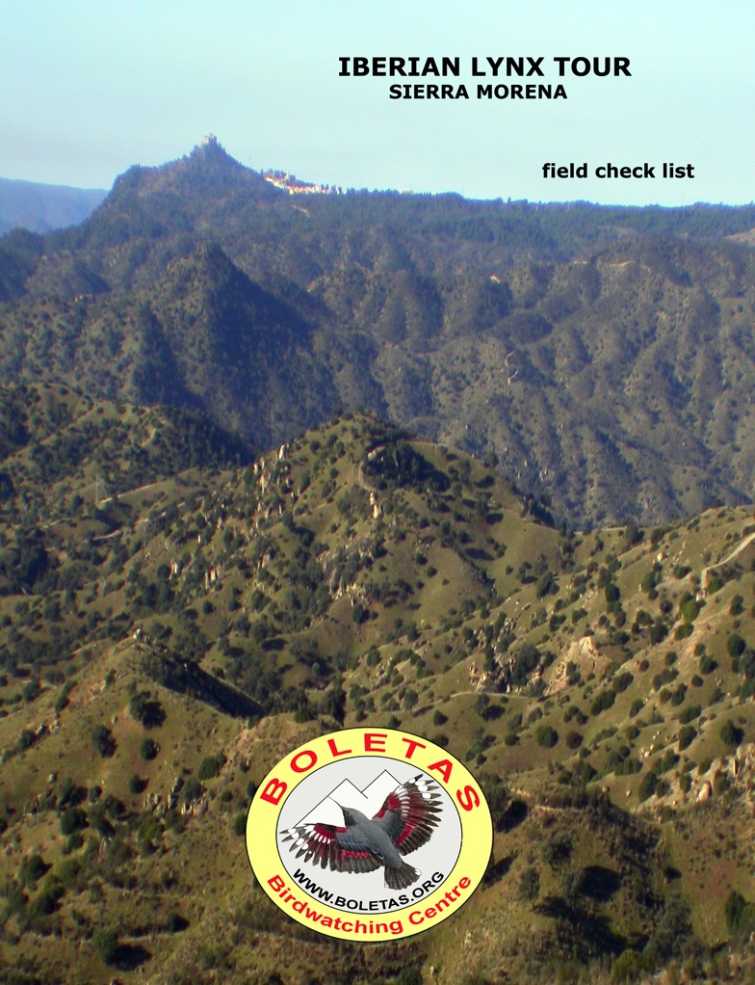
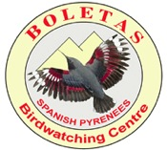
Birdwatching Holidays in Spain, Morocco & more…

BOLETAS Birdwatching centre
22192 Loporzano (Huesca) – Spain
tel/fax 00 34 974 262027 or 01162 889318
e.mail: jjsv@boletas.org
WWW.BIRDINGSPAIN.COM
Josele J. Saiz - NIF 38491538A

Birds of Andalucia

DAYLY REGISTER

Day 1- / ________________ weather_______________________________________________________________________
Itinerary______________________________________________________________________________________________

Day 2 -/________________ weather_______________________________________________________________________
Itinerary______________________________________________________________________________________________

Day 3-/________________ weather_______________________________________________________________________
Itinerary______________________________________________________________________________________________

Day 4- / ________________ weather_______________________________________________________________________
Itinerary______________________________________________________________________________________________

Day 5- / ________________ weather_______________________________________________________________________
Itinerary______________________________________________________________________________________________

Day 6- / ________________ weather_______________________________________________________________________
Itinerary______________________________________________________________________________________________

Day 7- / ________________ weather_______________________________________________________________________
Itinerary______________________________________________________________________________________________

Day 8- / ________________ weather_______________________________________________________________________
Itinerary______________________________________________________________________________________________

RECOMMENDED SIGNS:
Vista/Seen ( X ) Oida/Heard (H )Abundant (XXX) Common (XX) Rare (+) Juvenile (Juv) Immature (Inm) Adult (ad) Female Male

English Name | Latin Name | 1 | 2 | 3 | 4 | 5 | 6 | 7 | 8
Great Crested Grebe | Podiceps cristatus
Black-necked Grebe | Podiceps nigricollis
Little Grebe | Tachybaptus ruficollis
Great Cormorant | Phalacrocorax carbo
Grey Heron | Ardea cinerea
Little Egret | Egretta garzetta
Great Egret | Egretta alba
Cattle Egret | Bubulcus ibis
Squacco Heron | Ardeola ralloides
Black-crowned Night-Heron | Nycticorax nycticorax
Little Bittern | Ixobrychus minutus
Glossy Ibis | Plegadis falcinellus
Eurasian Spoonbill | Platalea leucorodia
White Stork | Ciconia ciconia
Black Stork | Ciconia nigra
Greylag Goose | Anser anser
Bean Goose | Anser fabalis
White-fronted Goose | Anser albifrons
Common Shelduck | Tadorna tadorna
Mallard | Anas platyrhynchos
Gadwall | Anas strepera
Eurasian Wigeon | Anas penelope
Common Teal | Anas crecca
Northern Pintail | Anas acuta
Northern Shoveler | Anas clypeata
Red-crested Pochard | Netta rufina
Tufted Duck | Aythya fuligula
Common Pochard | Aythya ferina
Ruddy Duck | Oxyura jamaicensis
Black Vulture | Aegypius monachus
Eurasian Griffon Vulture | Gyps fulvus
Osprey | Pandion haliaetus
Red Kite | Milvus milvus
Black-winged Kite | Elanus caeruleus
Bonelli's Eagle | Aquila fasciatus
Golden Eagle | Aquila chrysaetos
Spanish Imperial Eagle | Aquila adalberti
Northern Goshawk | Accipiter gentilis
Eurasian Sparrowhawk | Accipiter nisus
Common Buzzard | Buteo buteo
Eurasian Marsh Harrier | Circus aeruginosus
Hen Harrier | Circus cyaneus
English Name | Latin Name | 1 | 2 | 3 | 4 | 5 | 6 | 7 | 8
Peregrine Falcon | Falco peregrinus
Merlin | Falco columbarius
Common Kestrel | Falco tinnunculus
Red-legged Partridge | Alectoris rufa
Common Crane | Grus grus
Common Coot | Fulica atra
Purple Swamphen | Porphyrula porphyrula
Common Moorhen | Gallinula chloropus
Water Rail | Rallus aquaticus
Great Bustard | Otis tarda
Little Bustard | Tetrax tetrax
Pied Avocet | Recurvirostra avosetta
Black-winged Stilt | Himantopus himantopus
Northern Lapwing | Vanellus vanellus
European Golden-Plover | Pluvialis apricaria
Common Ringed Plover | Charadrius hiaticula
Little Ringed Plover | Charadrius dubius
Kentish Plover | Charadrius alexandrinus
Dunlin | Calidris alpina
Little Stint | Calidris minuta
Temminck's Stint | Calidris temminckii
Common Redshank | Tringa totanus
Common Greenshank | Tringa nebularia
Common Sandpiper | Tringa hypoleucos
Green Sandpiper | Tringa ochropus
Ruff | Philomachus pugnax
Eurasian Curlew | Numenius arquata
Black-tailed Godwit | Limosa limosa
Bar-tailed Godwit | Limosa lapponica
Eurasian Woodcock | Scolopax rusticola
Common Snipe | Gallinago gallinago
Jack Snipe | Lymnocryptes minimus
Stone Curlew | Burhinus oedicnemus
Black-headed Gull | Larus ridibundus
Yellow-legged Gull | Larus michahellis
Lesser Black-backed Gull | Larus fuscus
Little Tern | Sterna albifrons
Whiskered Tern | Chlidonias hybridus
Pin-tailed Sandgrouse | Pterocles alchata
Black-bellied Sandgrouse | Pterocles orientalis
Rock Dove | Columba livia
Feral Pigeon | Columba livia feral
Stock Dove | Columba oenas
Common Wood-Pigeon | Columba palumbus
Eurasian Collared-Dove | Streptopelia decaocto
Barn Owl | Tyto alba
English Name | Latin Name | 1 | 2 | 3 | 4 | 5 | 6 | 7 | 8
Eurasian Eagle-Owl | Bubo bubo
Long-eared Owl | Asio otus
Short-eared Owl | Asio flammeus
Little Owl | Athene noctua
Tawny Owl | Strix aluco
Common Kingfisher | Alcedo atthis
Eurasian Hoopoe | Upupa epops
Eurasian Wryneck | Jynx torquilla
Great Spotted Woodpecker | Dendrocopos major
Lesser Spotted Woodpecker | Dendrocopos minor
Eurasian Green Woodpecker | Picus viridis
Calandra Lark | Melanocorypha calandra
Skylark | Alauda arvensis
Woodlark | Lullula arborea
Crested Lark | Galerida cristata
Thekla Lark | Galerida theklae
Eurasian Crag-Martin | Hirundo rupestris
Barn Swallow | Hirundo rustica
House-Martin | Delichon urbica
Meadow Pipit | Anthus pratensis
Tawny Pipit | Anthus campestris
Water Pipit | Anthus spinoletta
White Wagtail | Motacilla alba
Grey Wagtail | Motacilla cinerea
Southern Grey Shrike | Lanius meridionalis
Dunnock | Prunella modularis
Alpine Accentor | Prunella collaris
Zitting Cisticola | Cisticola juncidis
Cetti's Warbler | Cettia cetti
Blackcap | Sylvia atricapilla
Sardinian Warbler | Sylvia melanocephala
Dartford Warbler | Sylvia undata
Common Chiffchaff | Phylloscopus collybita
Iberian Chiffchaff | Phylloscopus ibericus ibericus
Firecrest | Regulus ignicapillus
Goldcrest | Regulus regulus
Common Stonechat | Saxicola rubicola
Blue Rock-Thrush | Monticola solitarius
Northern Wheatear | Oenanthe oenanthe
Black Wheatear | Oenanthe leucura
Black Redstart | Phoenicurus ochruros
European Robin | Erithacus rubecula
Bluethroat | Luscinia svecica
Mistle Thrush | Turdus viscivorus
Fieldfare | Turdus pilaris
Redwing | Turdus iliacus
English Name | Latin Name | 1 | 2 | 3 | 4 | 5 | 6 | 7 | 8
Song Thrush | Turdus philomelos
Common Blackbird | Turdus merula
Long-tailed Tit | Aegithalos caudatus
Eurasian Penduline-Tit | Remiz pendulinus
Crested Tit | Parus cristatus
Blue Tit | Parus caeruleus
Coal Tit | Parus ater
Great Tit | Parus major
Eurasian Nuthatch | Sitta europaea caesia
Short-toed Treecreeper | Certhia brachydactyla
White-throated Dipper | Cinclus cinclus
Wren | Troglodytes troglodytes
Eurasian Jay | Garrulus glandarius
Eurasian Magpie | Pica pica
Iberian Azure-winged Magpie | Cyanopica cookii
Common Raven | Corvus corax
Carrion Crow | Corvus corone
Eurasian Jackdaw | Corvus monedula
Red-billed Chough | Pyrrhocorax pyrrhocorax
House Sparrow | Passer domesticus
Spanish Sparrow | Passer hispaniolensis
Eurasian Tree-Sparrow | Passer montanus
Common Starling | Sturnus vulgaris
Spotless Starling | Sturnus unicolor
Common Waxbill (introduced) | Estrilda astrild
Red Avadavat (introduced) | Amandava amandava
Brambling | Fringilla montifringilla
Chaffinch | Fringilla coelebs
Eurasian Bullfinch | Pyrrhula pyrrhula
European Serin | Serinus serinus
European Goldfinch | Carduelis carduelis
European Greenfinch | Carduelis chloris
Eurasian Siskin | Carduelis spinus
Eurasian Linnet | Carduelis cannabina
Red or Common Crossbill | Loxia curvirostra
Hawfinch | Coccothraustes coccothraustes
Rock Sparrow | Petronia petronia
Reed Bunting | Emberiza schoeniclus
Corn Bunting | Emberiza calandra
Cirl Bunting | Emberiza cirlus
Rock Bunting | Emberiza cia

Mammals of Andalucia

English Name | Latin Name | 1 | 2 | 3 | 4 | 5 | 6 | 7 | 8
Western Hedgehog | Erinaceus europaeus
Algerian Hedgehog | Atelerix algirus
Iberian Mole | Talpa occidentalis
Miller’s Water Shrew | Neomys anomalus
Greater White-toothed Shrew | Crocidura russula
Lesser White-toothed Shrew | Crocidura suaveolens
Pygmy White-toothed Shrew | Suncus etruscus
Lesser Horseshoe Bat | Rhinolophus hipposideros
Greater Horseshoe Bat | Rhinolophus ferrumequinum
Mediterranean Horseshoe Bat | Rhinolophus euryale
Mehely’s Horseshoe Bat | Rhinoluphus mehelyi
Bechtein's Bat | Myotis bechstinii
Daubenton’s Bat | Myotis daubentoni
Geoffroy’s Bat | Myotis emarginatus
Natterer’s Bat | Myotis nattereri
Greater Mouse-eared Bat | Myotis myotis
Lesser Mouse-eared Bat | Myotis blythi
Long-fingered Bat | Myotis capaccinii
Leisler’s Bat | Nyctalus leisleri
Noctule | Nyctalus noctula
Greater Noctule | Nyctalus Lasiopterus
Serontine | Eptesicus serotinus
Common Pipistrelle | Pipistrellus pipistrellus
Kuhl’s Pipistrelle | Pipistrellus kuhlii
Savi’s Pipistrelle | Pipistrellus savii
Grey Long-eared Bat | Plecotus austriacus
Schreiber’s Bat | Minipterus schreibersi
Free-tailed Bat | Tadarida teniotis
Wolf | Canis lupus signatus
Red Fox | Vulpes vulpes
Weasel | Mustela nivalis
Western Polecat | Mustela putorius
Beech Marten | Martes foina
Badger | Meles meles
Otter | Lutra lutra
Egyptian Mongoose | Herpestes ichneumon
Small-spotted Genet | Genetta genetta
Wild Cat | Felis silvestris
Iberian Lynx | Lynx pardinus
Wild Boar | Sus scrofa
Red Deer | Cervus elaphus
Fallow Deer | Dama dama
Roe Deer | Capreolus capreolus
Iberian Wild Goat | Capra pyrenaica
Mouflon | Ovis musimon
Red Squirrel | Sciurus vulgaris
Southern Water Vole | Arvicola sapidus
Snow Vole | Microtus nivalis
Mediterranean Pine Vole | Pitymys duodecimocostatus
Cabrera’s Vole | Microtus cabrerae
Wood Mouse | Apodemus sylvaticus
Black Rat | Rattus rattus
Brown Rat | Rattus norvegicus
House Mouse | Mus musculus
Algerian Mouse | Mus sprettus

